List of experiments on Socket Programming

- Write a programs in C: hello_client (The server listens for, and accepts, a single TCP connection; it reads all the data it can from that connection, and prints it to the screen; then it closes the connection)
- Write a programs in C: hello_server (The client connects to the server, sends the string “Hello, world!”, then closes the connection )
- Write a programs in C for TCP chat server
- Write a programs in C: hello_client (The server listens for, and accepts, a single UDP connection; it reads all the data it can from that connection, and prints it to the screen; then it closes the connection)
- Write a programs in C: hello_server (The client connects to the server, sends the string “Hello, world!”, then closes the connection )

List of experiments using Cisco Packet Tracer

- To demonstrate and configure a simple network topology using a switch.
- To demonstrate and configure a simple router for connecting two hosts using different gateways.
- To demonstrate and configure a DHCP server on a network
- To demonstrate and configure a DHCP server on a Router
- To demonstrate and configure a simple VLAN in the network
- To demonstrate and configure Switch Port Security
- To demonstrate and configure simple LAN and understand the concept and operation of Address Resolution Protocol (ARP)
- To demonstrate and configure Static Routing Configuration using two Routers
- To demonstrate and configure Routing Information Protocol (RIP) in the network.
- To demonstrate and configure multiple router networks and understand the operation of OSPF Protocol

Lab Objective: To configure a simple network topology using switch.
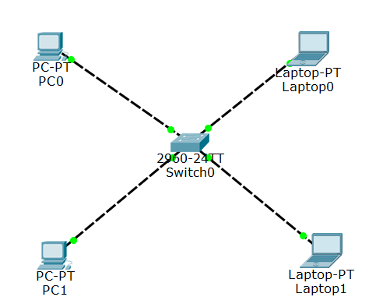

Steps to be followed on Cisco Packet Tracer
Step 1. Adding end devices for topology from bottom left corner:
- Click on End devices and select Generic PC (PC0) from second menu to immediate right. Add it to the sandbox screen.
- Similarly add one more Generic PC (PC1).
- Select Generic Laptop (Laptop0) to add laptop to your topology.
- Similarly add one more Generic Laptop (Laptop1).
- Now select a Switch (2960) from the same menu and add it to the sandbox screen.
Step 2. Adding Connections between the devices:
- Click on Connections (bottom-left corner menu) and select Copper cross-over cable for wired connection.
- Now click on PC0 and select FastEthernet0 type from dropdown menu.
- Now click on Switch0 and select FastEthernet0/1 type from dropdown menu.
- Similarly create connections between PC1 and Switch0, Laptop0 and Switch0, and Laptop1 and Switch0. Use separate FastEthernet (FastEthernet 0/ 1-24) on switch for each connection.
- Fast forward time so that all connections to the router get activated (green dots) by clicking on Fast Forward Time option above menu at bottom-left corner.
Step 3. Configuring the IP settings:
- Double-Click on PC0 for configuration menu. Click on Desktop tab and select IP configuration.
- Select static option for IP settings and assign IP address to the device, for example: 10.1.1.1
- Hit Enter (Return), the subnet mask will appear automatically. Otherwise fill appropriate mask manually.
- Close the PC0 window.
- Similarly assign IP addresses to other devise (PC1, Laptop0, Laptop1).
- Ensure that the devices have IP address of same class and same subnet mask.
Step 4. Sending data among the nodes:
- Click the packet icon on the right menu.
- Click on PC0 and then click PC1.
- Notification will appear at bottom-right corner for Successful transmission.
Assignment: Configure the network as shown below in the figure.
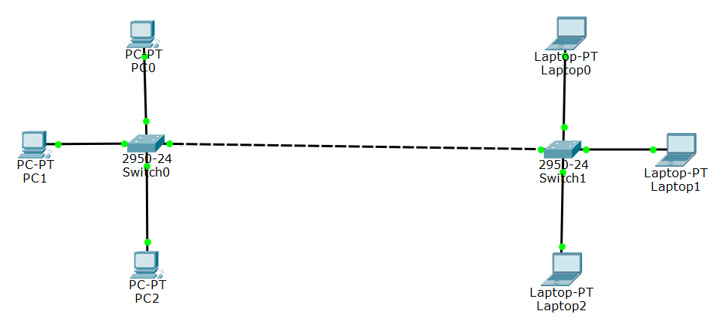

Lab Exercise No. 2
Objective: To demonstrate and configure a simple router for connecting two hosts using different gateways.
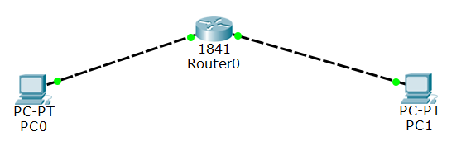
Steps to be followed on Cisco Packet Tracer
Step 1. Open Cisco Packet Tracer Application.
Step 2. Select end devices (Router 1841 and PCs) from the bottom left-hand corner and drag it to the sandbox screen.
Step 3. Now select connections from the same bottom left-hand corner. Create connections by selecting copper cross-over cable from the second menu to the immediate right.
Step 4. Click on Router0, and connect the cable via FastEthernet0/0. Now click the PC0 and select FastEthernet. Do the same operation to PC1, only this time connect the cable to FastEthernet0/1 since FastEthernet0/0 is already taken by PC0.
Step 5. Click on Router0 for configuration menu and verify that it is turned on. Click on CLI tab to access the configuration menu and follow these instructions:
- Enter no for the question asked and Press RETURN to start the session
- Type enable to get to privileged mode (this gives you more options in configuring the router)
- Type config terminal (or config t for short) to access the configuration menu.
- Type interface fastethernet0/0 to access Ethernet0/0
- Type ip address 192.168.10.1 255.255.255.0 to assign an IP address and subnet mask to the interface.
- Type no shutdown to open the interface up for business.
Step 6. Do the same for FastEthernet0/1:
- Press Ctrl + Z to go back to the previous mode.
- Type interface fastethernet0/1
- Type ip address 192.168.20.1 255.255.255.0
- Type no shutdown
Step 7. Configure Gateway on each computer:
- Click on PC0 to bring up the configuration menu.
- Under global settings you will find a field for the gateway. Enter the corresponding IP address of the router’s interface, which is 192.168.10.1.
- Then click the FastEthernet tab on the left column to set the actual computer’s IP address to be on the network. Use 192.168.10.2 for the IP address, and 255.255.255.0 for the subnet mask.
- Do the same thing for PC1, only use 192.168.20.1 for the gateway address, 192.168.20.2 for the IP address, and 255.255.255.0 for the subnet mask.
Step 8. Confirm that network works:
- Click the packet icon on the right menu.
- Click on PC0 and then click PC1.
- Notification will appear at bottom-right corner for Successful transmission.
Assignment: Configure the network as shown below in the figure.
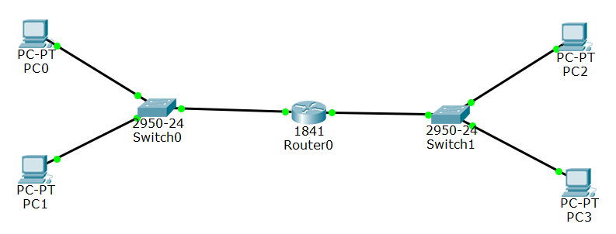
Lab Exercise No. 3
Objectives: To demonstrate and configure a network using DHCP server
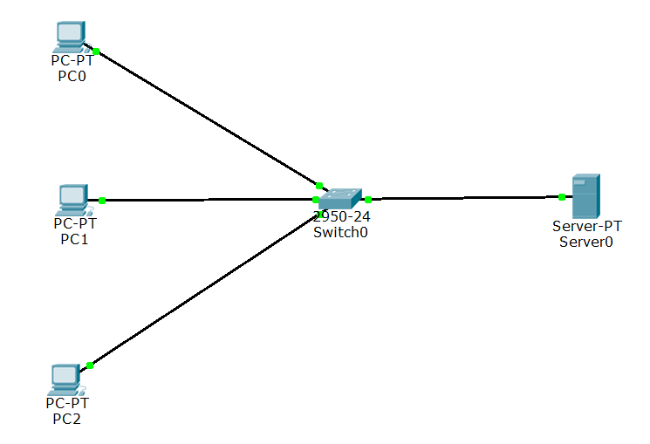
Theory
DHCP Server is a network server that automatically provides and assigns IP addresses, default gateways and other network parameters to client devices. It relies on the standard protocol known as Dynamic Host Configuration Protocol or DHCP to respond to broadcast queries by clients. A DHCP server automatically sends the required network parameters for clients to properly communicate on the network. Without it, the network administrator has to manually set up every client that joins the network, which can be cumbersome, especially in large networks. DHCP servers usually assign each client with a unique dynamic IP address, which changes when the client’s lease for that IP address has expired.

Steps to be followed on Cisco Packet Tracer
Step 1: Creating a LAN and server:
- Add a Switch (Switch0).
- Add a Server PT (Server0).
- Connect them using Copper Straight cable.
- Add 3 Generic PCs and connect them to Switch0 using Copper Straight cable.
Step 2: Click on Server for configuration menu, then go to Services tab.
Step 3: Turn the Service On by choosing On radio option.
Step 4: Go to Services tab and click on DHCP.
Step 5: Then edit Start IP address and assign IP and Subnet Mask:
IP: 10.0.0.10 and Subnet mask 255.0.0.0
Step 6: In Maximum Number of Users assign number if required (512 default).
Step 7: Click on Save.
Step 8: Go to Config tab and select FastEthernet0 from left side menu.
Step 9: Assign IP address and Subnet Mask. In this case assign IP: 10.0.0.1 and subnet mask 255.0.0.0 and close the window.
Step 10: Now, Click on any of the PC-> then click on Desktop->IP configuration, and Choose 'DHCP' wait for some time, if your DHCP request failed then try few more times.
- You can also add any new PC or Laptop to Switch0 and assign IP using DHCP.

Assignment: Configure the following network topology
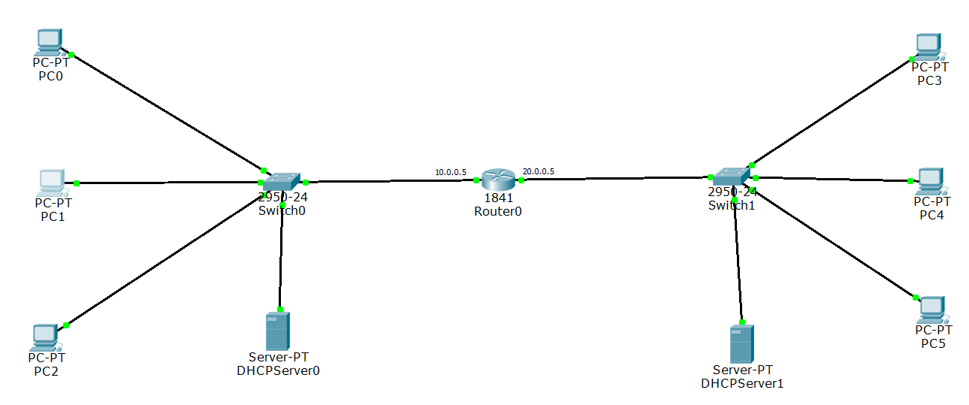

Lab Exercise No. 4
Objectives: To demonstrate and configure a DHCP server using Router
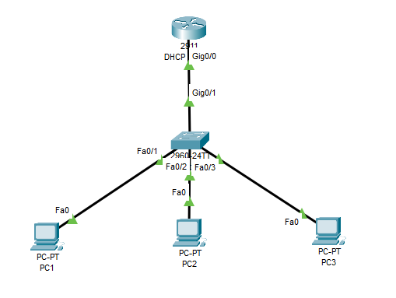
Theory
DHCP Server is a network server that automatically provides and assigns IP addresses, default gateways and other network parameters to client devices. It relies on the standard protocol known as Dynamic Host Configuration Protocol or DHCP to respond to broadcast queries by clients. A DHCP server automatically sends the required network parameters for clients to properly communicate on the network. Without it, the network administrator has to manually set up every client that joins the network, which can be cumbersome, especially in large networks. DHCP servers usually assign each client with a unique dynamic IP address, which changes when the client’s lease for that IP address has expired.

Steps to be followed on Cisco Packet Tracer
Step-1:
A network topology is created in the Cisco Packet Tracer, which includes a router, a switch, and three host systems connected to a network.
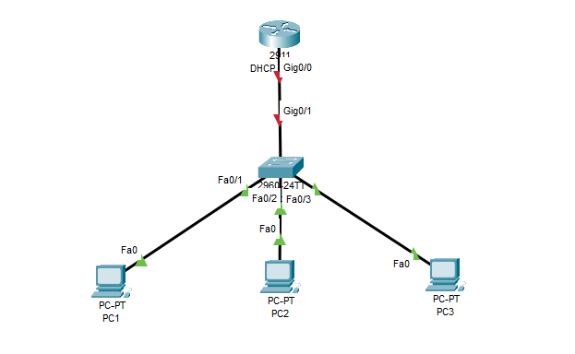
Fig: Network Topology
Step-2:
Command Line Interface of the router is accessed and high-lighted commands are executed to successfully configure the DHCP. At first, the ‘IP DHCP pool pool_name’ command is executed. After this, the network address is defined along with its subnet mask. And further, the ‘default-router IP-address’ command is used to define the default route address.
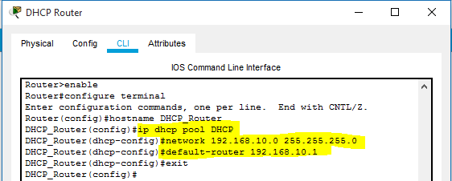
Fig: Creation of DHCP pool
Step-3:
In this step, a range of IP addresses is excluded from the addresses defined in the subnet mask of the DHCP pool. Excluded IP addresses will be not assigned to any host system in the network.
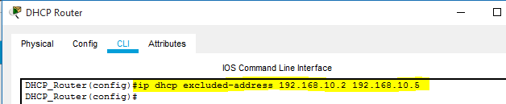
Fig: Command used to exclude IP range
Step-4:
The interface of the router connected with the switch is assigned with the IP address defined as the default router during the DHCP configuration. This route will be taken by the data packets to reach their destination system. Also, the ‘no shutdown command is used to change the state of the connected interface to up.
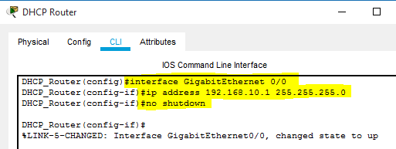
Fig: Assigning of IP address to router’s interface
Step-5:
A successful connection is established between all the devices connected in a network. In further steps, host systems in the network are assigned with dynamic IP and default gateway address by the DHCP service configured on the router.
Fig: All the devices are successfully connected
Step-6:
Desktop settings of a host system are accessed and the DHCP option is selected. DHCP request forwarded by the system is acknowledged and IP address, associated subnet mask, and default gateway address are assigned to it.
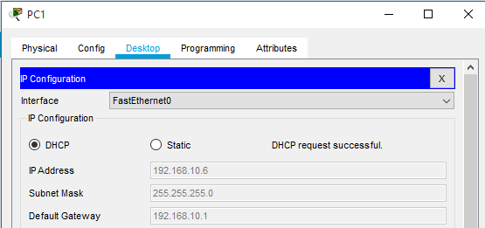
Fig: The dynamic IP address assigned to the Host System
Another host system deployed in the network is assigned with required logical addresses through the DHCP server configured on Cisco Router. In addition, IP addresses defined in the excluded range are not assigned to the computer systems.
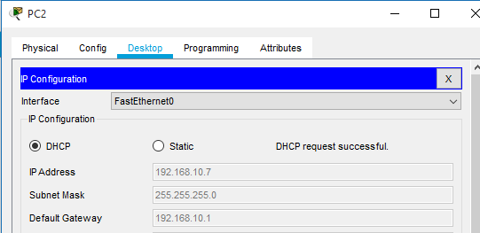
Fig: Logical addresses are assigned to the Host System
Step-7:
To check the connectivity between the host systems, the ‘ping’ command is used to exchange data packets. All the data packets are successfully transferred, which ensures that a communication channel is established.
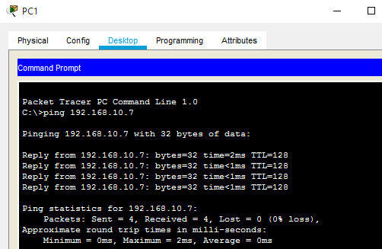

Lab Exercise No. 5
Objectives: To demonstrate and configure VLAN and inter-VLAN Routing
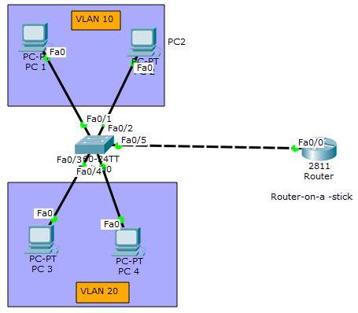
A VLAN is a switched network that is logically segmented by function, project team, or application, without regard to the physical locations of the users. VLANs have the same attributes as physical LANs, but you can group exit stations even if they are not physically located on the same LAN segment. Any switch port can belong to a VLAN, and unicast, broadcast, and multicast packets are forwarded and flooded only to exit stations in the VLAN. Each VLAN is considered a logical network, and packets destined for stations that do not belong to the VLAN must be forwarded through a router or a switch supporting fallback bridging. VLANs are identified by a number from 1 to 4094.
VLANs have similar characteristics with those of physical LANs, only that with VLANs, you can logically group hosts even if they are physically located on separate LAN segments. We treat each VLAN as a separate subnet or broadcast domain. For this reason, to move packets from one VLAN to another, we have to use a router or a layer 3 switch. VLANs are configured on switches by placing some interfaces into one broadcast domain and some interfaces into another.
Step 1: Create the above-mentioned network topology in Cisco Packet Tracer.
Step 2: Create 2 VLANs on the switch: VLAN 10 and VLAN 20.
Switch#config terminal
Switch(config)#vlan 10
Switch(config-vlan)#name SALES
Switch(config-vlan)#vlan 20
Switch(config-vlan)#name IT
Step 3: Assign switch ports to the VLANs.
Remember each VLAN is viewed as separate broadcast domain. And just before you configure, have in mind that switch ports could be either access or trunk.
- An access port is assigned to a single VLAN. These ports are configured for switch ports that connect to devices with a normal network card, for example a PC in a network.
- A trunk port on the other hand is a port that can be connected to another switch or router. This port can carry traffic of multiple VLANs.
So in our case, we’ll configure switch interfaces fa0/1 through fa0/4 as access ports to connect to our PCs. Here, interfaces fa0/1 and fa0/2 are assigned to VLAN 10 while interfaces fa0/3 and fa0/4 are assigned to VLAN 20.
Switch Interface fa0/5 will be configured as trunk port, as it will be used to carry traffic between the two VLANs via the router.
Switch>enable
Switch#config terminal
Switch(config)#int fa0/1
Switch(config-if)#switchport mode access
Switch(config-if)#switchport access vlan 10
Switch(config-if)#int fa0/2
Switch(config-if)#switchport mode access
Switch(config-if)#switchport access vlan 10
Switch(config-if)#int fa0/3
Switch(config-if)#switchport mode access
Switch(config-if)#switchport access vlan 20
Switch(config-if)#int fa0/4
Switch(config-if)#switchport mode access
Switch(config-if)#switchport access vlan 20
In the above commands, we have specified an interface range and then proceeded to configure all the ports specified as access ports.
Interface fa0/5 is configured as trunk and will be used to for inter-VLAN communication.
Switch(config)#int fa 0/5
Switch(config-if)#switchport mode trunk
Step 4: Assign static IP addresses to the four PCs which are located in the separate VLANs.
PC1 and PC2 fall in VLAN 10 while PC3 and PC4 fall in VLAN 20.
PC1: IP address 192.168.1.10 Subnet mask 255.255.255.0 Default gateway 192.168.1.1
PC2: IP address 192.168.1.20 Subnet mask 255.255.255.0 Default gateway 192.168.1.1
PC3: IP address 192.168.2.10 Subnet mask 255.255.255.0 Default gateway 192.168.2.1
PC4: IP address 192.168.2.20 Subnet mask 255.255.255.0 Default gateway 192.168.2.1
And now it’s very clear that we treat a VLAN just like a physical LAN when assigning IP addresses.
At this point let’s try to test connectivity within VLANs and between VLANs
To test communication between hosts in the same VLAN:
Ping PC2 from PC1 both in VLAN 10. Ping test should be successful.
To test connectivity between hosts in different VLANs:
Ping PC3 in VLAN 20 from PC1 in VLAN 10. Ping here will definitely fail. Because inter-VLAN routing is not yet enabled. Hope you can see how we’ve used VLANs to place the hosts into two logical networks which can be viewed as separate broadcast domains.
Now, in order to allow the hosts in the two VLANs to communicate, we need to do something extra. And you can guess what. We’ll configure the router to permit inter-VLAN communication.
Step 5: Configure inter-VLAN routing on the router
We’ll configure the router so that it will enable communication between the two VLANs via a single physical interface. How this is made possible? We’ll divide the single physical interface on the router into logical interfaces (sub interfaces). Each sub-interface will then serve as a default gateway for each of the VLANs. This scenario is called router on a stick (R.O.A.S) and will allow the VLANs to communicate through the single physical interface.
Wort noting: We can’t assign an IP address to the router’s physical interface that we have subdivided into logical sub-interfaces. We’ll instead assign IP addresses to the sub interfaces. So let’s do router configurations:
Router>enable
Router#config terminal
Router(config)#int fa0/0
Router(config-if)#no shutdown
Router(config-if)#int fa0/0.10
Router(config-subif)#encapsulation dot1q 10
Router(config-subif)#ip add 192.168.1.1 255.255.255.0
Router(config-subif)#
Router(config-subif)#int fa0/0.20
Router(config-subif)#encapsulation dot1q 20
Router(config-subif)#ip add 192.168.2.1 255.255.255.0
As you can notice from above, the routers physical interface fa0/0 was subdivided into two sub-interfaces (fa0/0.10 and fa0/0.20), which are then configured as trunk interfaces and given IP addresses.
Step 6: Test inter-VLAN connectivity.
Here we’ll test connectivity between computers in different VLANs. Don’t forget that it’s the router that enables inter-VLAN routing.
Ping PC3 in VLAN 20 from PC1 in VLAN 10. If everything is well configured, then ping should work perfectly.

Lab Exercise No. 6
Objectives: To configure and demonstrate the Static Routing Configuration using two Routers

Step 1: Creating topology:
- Add 2 Switches (Switch0-1).
- Add 2 Routers-1841 (Router0-1).
- Connect them using Copper Straight cable.
- Add 4 Generic PCs (PC0-3). Connect PC0 and PC1 to Switch0 using Copper Straight cable and connect PC2 and PC3 to Switch1.
- Connect Switch0 to Router0 (FastEthernet0/0) and Switch1 to Router1 (FastEthernet0/0) using Copper Straight cable.
- Connect two Routers (FastEthernet0/1) using Copper crossover cable
Step 2: In PC0, go to its Desktop panel and select IP configuration. Give IP address, Subnet Mask, and Gateway. Give IP address, mask and Gateway to PC1. Do the same with another two (PC2-PC3).
- PC0-PC1: 1.0.0.1 and 1.0.0.2 resp. Mask: 255.0.0.0 Gateway: 1.0.0.5
- PC2-PC3: 3.0.0.1 and 3.0.0.2 resp. Mask: 255.0.0.0 Gateway: 3.0.0.5
Step 3: Now for Router Configuration, Click on Router1 and go to CLI tab. Press Enter and type following commands:
- Router>enable
Router#configure terminal
Enter configuration commands, one per line. End with CNTL/Z.
Router(config)#interface fa0/0
Router(config-if)#ip address 3.0.0.5 255.0.0.0
Router(config-if)#no shutdown
Router(config-if)#
%LINK-5-CHANGED: Interface FastEthernet0/0, changed state to up
%LINEPROTO-5-UPDOWN: Line protocol on Interface FastEthernet0/0, changed state to up
- Router(config-if)#exit
Router(config)#interface fa0/1Router(config-if)#ip address 2.0.0.2 255.0.0.0
Router(config-if)#no shutdownRouter(config-if)#
%LINK-5-CHANGED: Interface FastEthernet0/1, changed state to up
- Router(config-if)#exit
Step 4: Similarly to configure other router (Router0), type these commands:
- Router>enable
Router#configure terminal
Enter configuration commands, one per line. End with CNTL/Z.
Router(config)#interface fa0/0
Router(config-if)#ip address 1.0.0.5 255.0.0.0
Router(config-if)#no shutdown
Router(config-if)#
%LINK-5-CHANGED: Interface FastEthernet0/0, changed state to up
%LINEPROTO-5-UPDOWN: Line protocol on Interface FastEthernet0/0, changed state to up
Router(config-if)#exit
Router(config)#interface fa0/1
Router(config-if)#ip address 2.0.0.1 255.0.0.0
Router(config-if)#no shutdown
Router(config-if)#
%LINK-5-CHANGED: Interface FastEthernet0/1, changed state to up
%LINEPROTO-5-UPDOWN: Line protocol on Interface FastEthernet0/1, changed state to up
Router(config-if)#exit
Step 6: Now go to Router0 and type
Router(config)#ip route 3.0.0.0 255.0.0.0 2.0.0.2
Step 7: Now go to other router (Router1) and type
Router(config)#ip route 1.0.0.0 255.0.0.0 2.0.0.1
Step 8: Verify connections by ping command. Select one of the devices, go to its command prompt and type ping ip-address.

Lab Exercise No. 7
Objectives: To configure and verify three Router connections using RIP Routing Protocol.
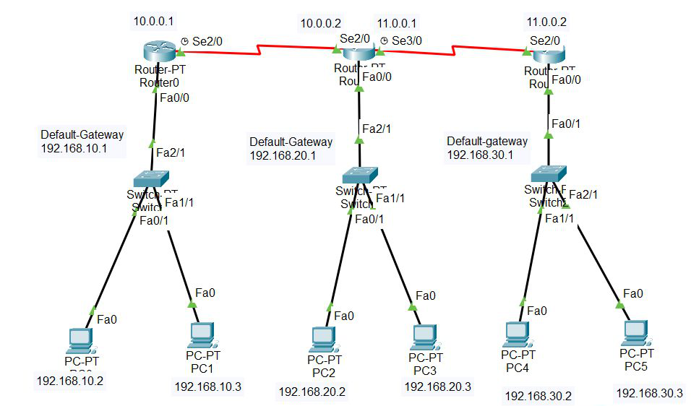

Routing Information Protocol (RIP) is an active routing protocol that operates hop count as a routing metric to find the most suitable route between the source and the destination network. It is a distance-vector routing protocol that has an AD value of 120 and works on the Network layer of the OSI model.

Step 1: Open the Cisco packet tracer desktop and select the devices given below:
S.NO | Device | Model Name | Qty.
1. | PC | PC | 6
2. | Switch | PT-Switch | 3
3. | Router | PT-router | 3

IP Addressing Table:
S.NO | Device | IPv4 Address | Subnet mask | Default Gateway
1. | PC0 | 192.168.10.2 | 255.255.255.0 | 192.168.10.1
2. | PC1 | 192.168.10.3 | 255.255.255.0 | 192.168.10.1
3. | PC2 | 192.168.20.2 | 255.255.255.0 | 192.168.20.1
4. | PC3 | 192.168.20.3 | 255.255.255.0 | 192.168.20.1
5. | PC4 | 192.168.30.2 | 255.255.255.0 | 192.168.30.1
6. | PC5 | 192.168.30.3 | 255.255.255.0 | 192.168.30.1

Then, create a network topology as shown below the image.
Use an Automatic connecting cable to connect the devices with others.
Step 2: Configure the PCs (hosts) with IPv4 address and Subnet Mask according to the IP addressing table given above.
- To assign an IP address in PC0, click on PC0.
- Then, go to desktop and then IP configuration and there you will IPv4 configuration.
- Fill IPv4 address and subnet mask.
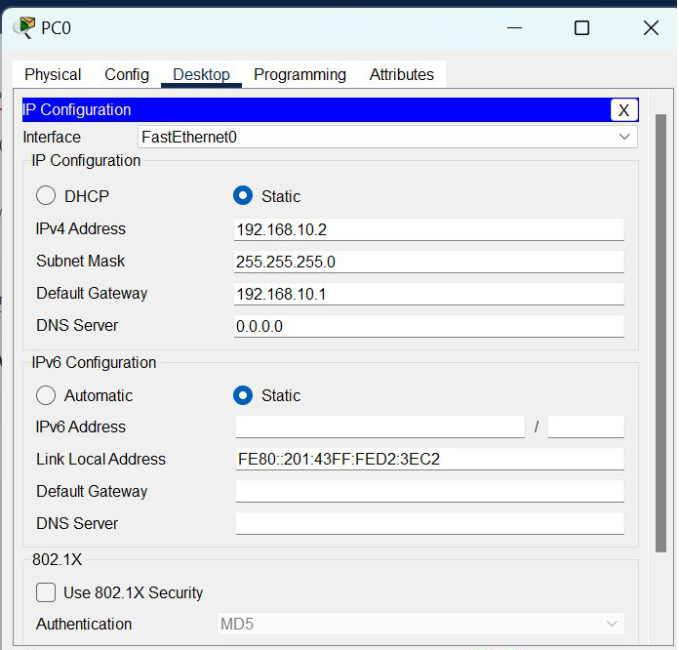
- Assigning an IP address using the ipconfig command, or you can also assign an IP address with the help of a command.
- Go to the command terminal of the PC.
- Then, type ipconfig <IPv4 address><subnet mask><default gateway>(if needed)
- Example: ipconfig 192.168.10.2 255.255.255.0 192.168.10.1
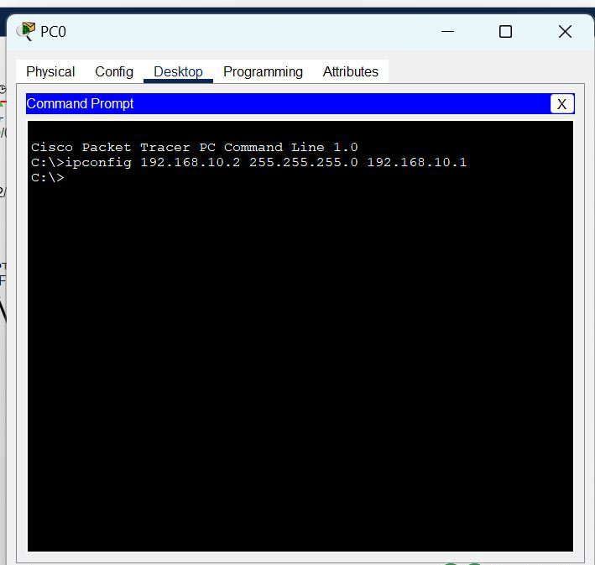

- Repeat the same procedure with other PCs to configure them thoroughly.

Step 3: Configure router with IP address and Subnet mask.
IP Addressing Table Router:
S.NO | Device | Interface | IPv4 Address | Subnet mask
1. | router0 | FastEthernet0/0 | 192.168.10.1 | 255.255.255.0
1. | router0 | Serial2/0 | 10.0.0.1 | 255.0.0.0
2. | router1 | FastEthernet0/0 | 192.168.20.1 | 255.255.255.0
2. | router1 | Serial2/0 | 10.0.0.2 | 255.0.0.0
2. | router1 | Serial3/0 | 11.0.0.1 | 255.0.0.0
3. | router2 | FastEthernet0/0 | 192.168.30.1 | 255.255.255.0
3. | router2 | Serial2/0 | 11.0.0.2 | 255.0.0.0

- To assign an IP address in router0, click on router0.
- Then, go to config and then Interfaces.
- Make sure to turn on the ports.
- Then, configure the IP address in FastEthernet and serial ports according to IP addressing Table.
- Fill IPv4 address and subnet mask.
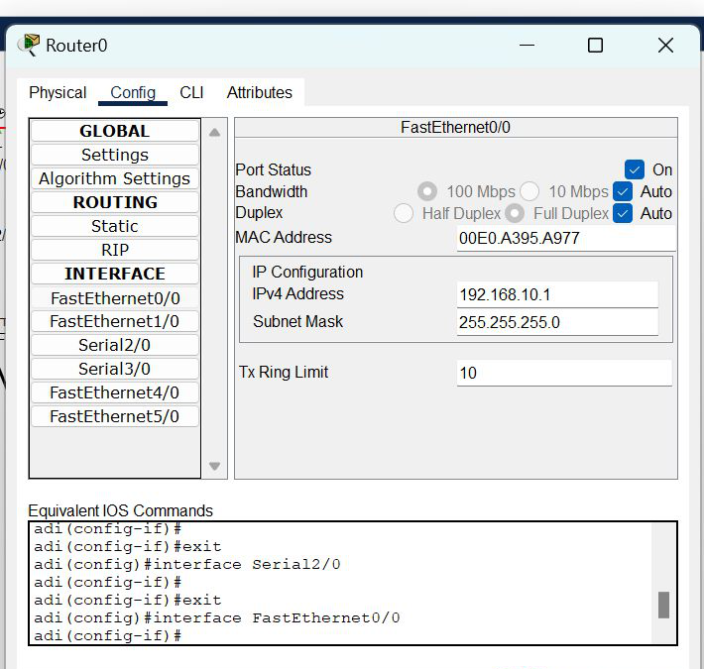
- Repeat the same procedure with other routers to configure them thoroughly.

Step 4: After configuring all of the devices you need to assign the routes to the routers.
- To assign RIP routes to the particular router:
- First, click on router0 then Go to CLI.
- Then type the commands and IP information given below.
CLI command : router rip
CLI command : network <network id>
RIP Routes for Router0 are given below:
Router(config)#router rip
Router(config-router)#network 192.168.10.0
Router(config-router)#network 10.0.0.0
RIP Routes for Router1 are given below:
Router(config)#router rip
Router(config-router)#network 192.168.20.0
Router(config-router)#network 10.0.0.0
Router(config-router)#network 11.0.0.0
RIP Routes for Router2 are given below:
Router(config)#router rip
Router(config-router)#network 192.168.30.0
Router(config-router)#network 11.0.0.0

Step 5: Verifying the network by pinging the IP address of any PC.
- You will use the ping command to do so.
- First, click on PC0 then Go to the command prompt.
- Then type ping <IP address of targeted node>. Example : ping 192.168.20.2
- You will get replies which means the connection is working properly.

